PAPER TITLE
The template is designed for three authors, this is limited to authors.
Prof. Pancho Tomov, PhD
Technical University of Sofia (Bulgaria)
Prof. Stiliyan Nikolov, PhD
Technical University of Sofia (Bulgaria)
Assoc. Prof. Reneta Dimitrova, PhD
Technical University of Sofia (Bulgaria)

Abstract. This electronic document is a template and already defines the components of your paper [title, text, heads, etc.] in its style sheet. Do Not Use Symbols, Special Characters, Footnotes, or Math in Paper Title or Abstract.
Keywords: component, formatting, style, styling, insert

1. Introduction
This template provides authors with most of the formatting specifications needed for preparing electronic versions of their papers. All standard paper components have been specified for three reasons: ease of use when formatting individual papers, automatic compliance to electronic requirements that facilitate the concurrent or later production of electronic products, and conformity of style throughout a conference proceeding…

2. Ease of Use
Confirm that you have the correct template for your paper size. This template has been tailored for output on the A4 paper size. The template is used to format your paper and style the text. All margins, line spaces, and text fonts are prescribed; please do not alter them. You may note peculiarities. This measurement and others are deliberate, using specifications that anticipate your paper as one part of the entire proceedings, and not as an independent document. Please do not revise any of the current designations …

3. Prepare Your Paper Before Styling
Before you begin to format your paper, first write and save the content as a separate text file. Do not number text heads-the template will do that for you.
Use either SI (MKS) or CGS as primary units. (SI units are encouraged.) English units may be used as secondary units (in parentheses). An exception would be the use of English units as identifiers in trade, such as “3.5-inch disk drive”.
Avoid combining SI and CGS units, such as current in amperes and magnetic field in oersteds. This often leads to confusion because equations do not balance dimensionally. If you must use mixed units, clearly state the units for each quantity that you use in an equation.
Do not mix complete spellings and abbreviations of units: “Wb/m2” or “webers per square meter”, not “webers/m2”. Spell out units when they appear in text: “. . . a few henries”, not “. . . a few H”.
Use a zero before decimal points: “0.25”, not “.25”. Use “cm3”, not “cc”.
You will need to determine whether or not your equation should be typed using either the Arial or the Symbol font (please no other font).
Number equations consecutively. Equation numbers, within parentheses, are to position flush right, as in (1), using a right tab stop. To make your equations more compact, you may use the solidus ( / ), the exp function, or appropriate exponents. Use a long dash rather than a hyphen for a minus sign.

$A=πr^{2}$ (1)

Note that the equation is centered using a center tab stop. Be sure that the symbols in your equation have been defined before or immediately following the equation. Use “(1)”, not “Eq. (1)” or “equation (1)”, except at the beginning of a sentence: “Equation (1) is . . .”
Place figures in the middle of the sheet. Place tables on the right of the sheet. Figure captions should be below the figures; table heads should appear above the tables. Insert figures and tables after they are cited in the text. Use the abbreviation “Fig. 1”, even at the beginning of a sentence.

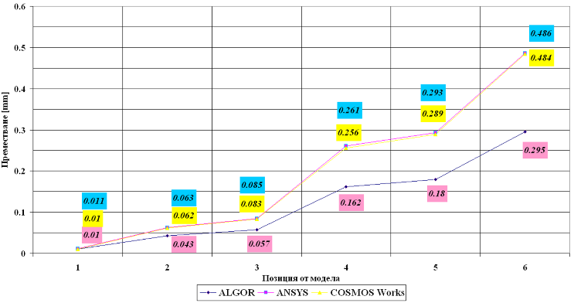

Fig.1. Example of a figure caption. (figure caption)
Table I. Type Styles
Table Head | Table Column Head
 | Subhead | Subhead | Subhead
Row

We suggest that you use Insert Pictures (which is ideally a 300 dpi).

Conclusions and summary
…

Acknowledgement
The work was supported and funded by […], [grant number XXX]
The author would like to acknowledge the employees at the …..
The preferred spelling of the word “acknowledgment” in America is without an “e” after the “g”. Avoid the stilted expression “one of us (R. B. G.) thanks ...”. Instead, try “R. B. G. thanks...”. Put sponsor acknowledgments in the unnumbered footnote on the first page.

REFERENCES
MALAKOV, I.; ZAHARINOV, V., 2014. Computer Aided Determination of Criteria Priority for Structural Optimization of Technical Systems. 24th DAAAM International symposium on intelligent manufacturing and automation. Vol. 69, pp. 735 – 744. [viewed 25 January 2025]. Available from: https://doi.org/10.1016/j.proeng.2014.03.049.
DIMITROV, S.; TOTEV, D.; LAZAROVA, А., 2023. Development of electrical and software part of an automated system for sowing, watering and chemical treatment, AIP Conference Proceeding, Vol. 3063, Issue: 1, pp. 060006. DOI: 10.1063/5.0195893.
MANOCHA, D.; CANNY, J., 2002. Efficient inverse kinematics for general 6R manipulators. IEEE Transactions on Robotics and Automation. Vol. 10, Issue: 5, pp. 648 – 657. DOI: 10.1109/70.326569. ISSN 1042 296X.
The presentation of literary sources in the list of literature is in accordance with BDS ISO 690:2021 (Harvard system). The list of references should contain literary sources that are available for checking or reference.

Prof. Pancho Tomov, PhD
ORCID iD: 0000-0003-1649-6947
Web of Science Researcher ID: AAH-3804-2019
Technical University of Sofia
Sofia, Bulgaria
E-mail: pkt@tu-sofia.bg

Prof. Stiliyan Nikolov, PhD
ORCID iD: 0000-0002-2485-3847
Web of Science Researcher ID: ACY-7901-2022
Technical University of Sofia
Sofia, Bulgaria
E-mail: st_nikolov2@tu-sofia.bg

Assoc. Prof. Reneta Dimitrova, PhD
ORCID iD: 0000-0001-6594-131X
Web of Science Researcher ID: GWZ-2447-2022
Technical University of Sofia
Sofia, Bulgaria
E-mail: rkd@tu-sofia.bg

